**ALY 6030 - MySQL – Project 2**

**edX Data Modeling**

**Submitted by:____________________________**

**Date:____________________**

**Overview**

In this project, you will build the data model from a dataset that contains users who took courses taught on the edX platform. These data are provided to you as a single Excel spreadsheet, almost exactly as they were made available from the original website. There are data for over 500,000 course registrations, from users around the world, to courses offered in 17 different sessions. We will look at a subset of the data, about 63,000 rows.

In order to make inferences from this dataset, we’ll need to clean up certain fields and also make some adjustments to the data model. This is a common task to undertake for customers or clients. They’ll often hand you data for analysis in a giant Excel sheet, and it will be your job to understand the business rules underpinning the dataset.

**Reminder: What constitutes a data model?**

Entities: objects

e.g. distribution center

Attributes: properties of objects

e.g. distribution center address

Primary keys: unique key for one record

e.g. distribution center ID number (or name)

Foreign keys: column that references another column in a different table (often PK)

e.g. factory ID or name

note: the foreign key must exist in the table being referenced

Relationships: “How many of one entity are related to another entity”

e.g. 1 warehouse serves *n* stores

Referential integrity: every value of a foreign key must exist in another table

e.g. factory name must exist in factory table

**Exploring the dataset**

It’s frequently helpful (especially if the dataset is small enough) to open it in Excel and manually inspect it. There are other tools you can use to inspect large files, and there are also tools that you can use to manipulate them if needed (you’ve already seen how to do some of this in R.)

If you open up the dataset in Excel, you can take a look at it quickly to see what it looks like and what data are included.

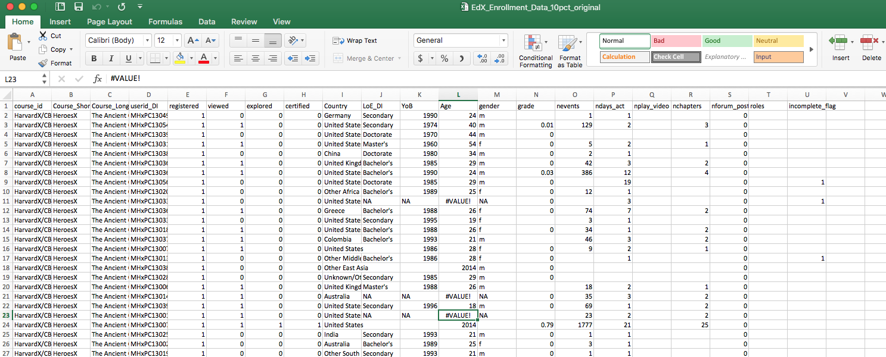

The data that are available as you build the database include:

|  |  |
| --- | --- |
| Column Name | Description |
| course_id | three-part identifier for a course number |
| Course Short Title | Short title for the course |
| Course Long Title | Long title for the course |
| userid_DI | Individual user ID |
| registered | Whether the user is registered (1/0) |
| viewed | Whether the user has viewed the contents (1/0) |
| explored | Whether the user has explored the course (1/0) |
| certified | Whether the user is certified (1/0) |
| Country | User’s country of origin |
| LoE_DI | User’s level of education |
| YoB | User’s year of birth |
| Age | User’s age |
| gender | User’s gender |
| grade | User’s grade in the course |
| nevents | Number of events the user has done on the site |
| ndays_act | Number of actions taken by the user |
| nplay_video | Number of video plays done by the user |
| nchapters | Number of chapters read by the user |
| nforum_posts | Number of forum posts made by the user |
| roles | Any roles the user has |
| incomplete_flag | Whether the user has an incomplete for the course |

**Some preliminary questions:**

1. The first thing to think about is what each row in this dataset represents. What do you think each row uniquely represents if you had to say it in a phrase?
2. Are there any fields that have heavily replicated data? Why?

**Brief note about column names:** Database queries can get tricky if there are spaces in any of the column names. Are there any columns that have spaces? In this example, columns B and C were originally called “Course Short Name” and “Course Long Name”. This makes the syntax harder to write out when you want to make queries. We have changed these fields to “course_short_name” and “course_long_name” for consistency with the other fields and also so that they will be easier to query later.

1. Let’s take a deeper look at the contents of the fields. There are a few things that look tricky about this data that might make it hard to put in a database correctly. Some fields are composites of several pieces of data. For example, the very first field, course_id, seems to have three parts, which actually relate to three different pieces of data. What data do they represent and how would you take the information in this single column and convert it to be more ready for database analysis?

1. Do you see any columns which have weird values or no values? What do you think explains this and do we need to do anything to address this now?

1. What do the 0 and 1 values in the registered and viewed columns represent?
2. What is the range of the grade values? Is it traditional 0-100 scoring, and how is the data stored?
3. What about data in the last seven columns? Are missing values okay here?

Now that you’ve looked over the data, we can pick appropriate data types for each column.

1. What is the most appropriate type of data for each of these columns given the values you have observed?

|  |  |
| --- | --- |
| Column Name | Data Type |
| course_id |  |
| Institution |  |
| Course_number |  |
| Course_term |  |
| Course Short Title |  |
| Course Long Title |  |
| userid_DI |  |
| registered |  |
| viewed |  |
| explored |  |
| certified |  |
| Country |  |
| LoE_DI |  |
| YoB |  |
| Age |  |
| gender |  |
| grade |  |
| nevents |  |
| ndays_act |  |
| nplay_video |  |
| nchapters |  |
| nforum_posts |  |
| roles |  |
| incomplete_flag |  |

**D. Updating the data model**

In this part of the activity, we will build a data model for the EdX data that will be cleaner and easier to use for queries. A recommended set of steps is given, although you are free to approach this as you wish.

1. First, we need to decide which of our database columns are attributes, which are entities, and which seem to be both. We have included Institution, course_number, and course_term, which were the three fields

|  |  |
| --- | --- |
| Column Name | Entity, Attribute, or Both? |
| course_id |  |
| Institution |  |
| Course_number |  |
| Course_term |  |
| Course Short Title |  |
| Course Long Title |  |
| userid_DI |  |
| registered |  |
| viewed |  |
| explored |  |
| certified |  |
| Country |  |
| LoE_DI |  |
| YoB |  |
| Age |  |
| gender |  |
| grade |  |
| nevents |  |
| ndays_act |  |
| nplay_video |  |
| nchapters |  |
| nforum_posts |  |
| roles |  |
| incomplete_flag |  |

1. What are the major entities that are needed to represent all of the data stored in this dataset? Each row in the dataset represents a student taking a specific course, which is something we should try and represent. We also know that there is information about courses, such as the institution the course it taught at, and information about users, such as their home country and education level. Try to determine which are the major entities to put in your data model that capture these main ideas, and then decide which attributes go into each entity.

Complete this part before seeing the next page.

Now that we know the three major entities that we will create in this database project, let’s define them each one by one.

1. First define the **Courses** entity. This table defines a unique course offered at EdX. What are the attributes that define a course that is available?

|  |
| --- |
| Courses |
|  |
|  |
|  |
|  |
|  |
|  |
|  |
|  |
|  |
|  |
|  |

1. Now, define the **Users** entity. This defines only data about a specific user on the EdX platform, not which courses that user is in. Decide what attributes should be put into this entity.

|  |
| --- |
| Users |
|  |
|  |
|  |
|  |
|  |
|  |
|  |
|  |
|  |
|  |
|  |

1. Finally, we need to capture some way to describe which courses each user is in, how much progress he or she has made in exploring the course materials, a grade (if applicable) and how many interactions the user has had on the EdX web platform. Define the **Course_Users** entity, which will contain this information for each course registration.

|  |
| --- |
| Course_Users |
|  |
|  |
|  |
|  |
|  |
|  |
|  |
|  |
|  |
|  |
|  |
|  |
|  |
|  |
|  |

**Keys**

Now we will pick the field or fields that will serve as the primary key for each table. The primary key must uniquely identify the row, so it cannot be duplicated and it cannot be null, or empty. Why can’t the primary key be repeated or empty?

1. What is the best key or keys to use for the **Courses** table? What are the possible choices of key(s)? What would the different choices change in what each row in Courses represents?

1. What is the best key or keys to use for the **Users** table?
2. What is the best key or keys to use for the **User_Courses** table?

**Relationships**

1. Now we will focus on how the tables relate to one another. Think first about the multiplicity of the relationships between each table.
2. What is the relationship between Users and Courses?

1. What is the relationship between Users and Course_Users?
2. What is the relationship between Courses and Course_Users?
3. Now let’s draw a relationship diagram (also called an entity-relationship or ER diagram.) First draw out all three tables together, and then draw the links between the tables. Place the appropriate connector (one to many, many to many, or one to one) between each table. Draw the lines from the specific linking field in one table to the same linking field in another table. You may use the Microsoft Paint or Paintbrush (Mac) to draw the ER diagram.